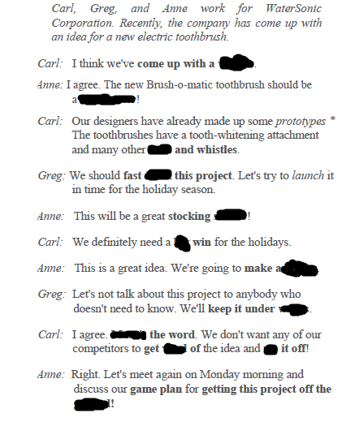

**blockbuster ,winner , ground, bells , stuffer , rip , mum’s , wind , track , big, killing, wraps**

**Projects:**

**We had a lot of turmoil when project entered full s………………………**

**v………………………….is highly sought during this phase**

**Due to our client’s change of request we had to get back to the d……………………………..board**

**c……………………….plan is required to avert unforeseeable circumstances**

**I…………………………leadership can put the project at stake**

**Out of s…………………………team can lead project towards failure**

**We should come up with d………………………….in few days**

**Lack of communication i……………………….progress and brought about deluge of complaints**

**o…………………………………of difficulties was unavoidable following fading interest of our clients in project’s outcome**

**Our clients didn’t exhibit v…………………………interest when we brought up revolutionary idea**

**d…………………………timeline is what kills project from inside**

**Due to poor a……………………………project failed**

**We came in u…………………………….budget albeit at the beginning it appered infeasible**

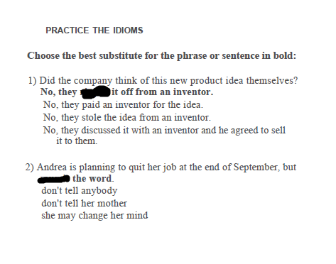

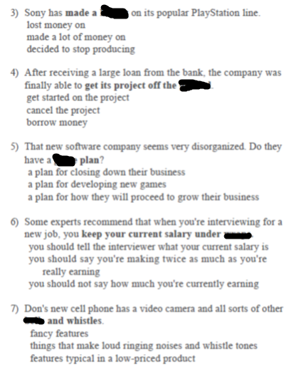

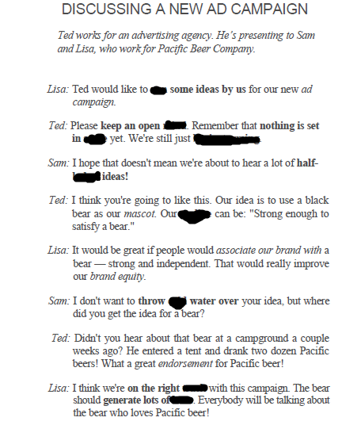

**, track , buzz , cold , baked , mind , brainstorming , run , stone , tagline**

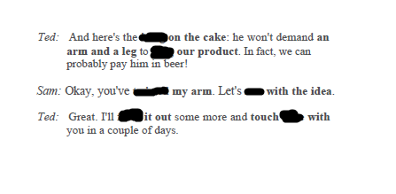

**twist , plug , icing , base , run , base**

